Module 3
​Allocating and Organising Staff

 | 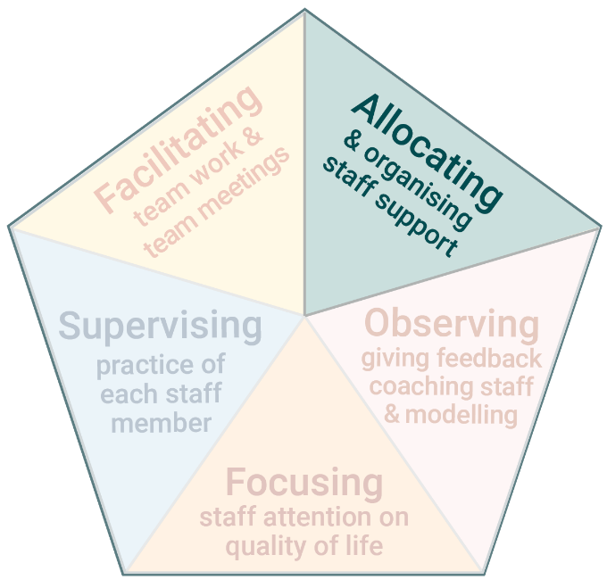 | ​​The second task of Practice Leadership is Allocating and Organising staff.  ​Frontline Practice Leaders organise and support staff to work individually and as a team. This helps ensure:  - Support is provided when and how each person you support wants and needs it.  - Consistency across staff in the way they work and provide support.

www.practiceleadershipresource.com.au/module3

Module 3 Activities
Watch the video Poor shift planning and answer the following questions.
Activity 3.1 Poor shift planning
- What problems did you see with the way staff were organised in this scenario?
- What impact did it have on each person who was being supported?
- If you were the Frontline Practice Leader in this service, what would you do to improve how staff were organised?

Activity 3.2 Good shift planning
Watch the video Good shift planning and answer the following questions.
- What did the staff do differently in this scenario, compared to the previous video?
- What impact did it have on each person who was being supported?
- If you were the Frontline Practice Leader, how would you set the expectation that this way of planning and organising among staff needs to happen every shift?

Activity 3.3 Inconsistent support
Watch the video Coffee three ways and answer the following questions.
- What would it be like for the person receiving support in three different ways to make their coffee?
- Imagine you are the Practice Leader in this service: What would you do to establish consistency in how staff support this person to make his coffee?

