Module 4 – Part 1
Observing Staff, Giving Feedback,
Coaching and Modelling Good Practice

 | 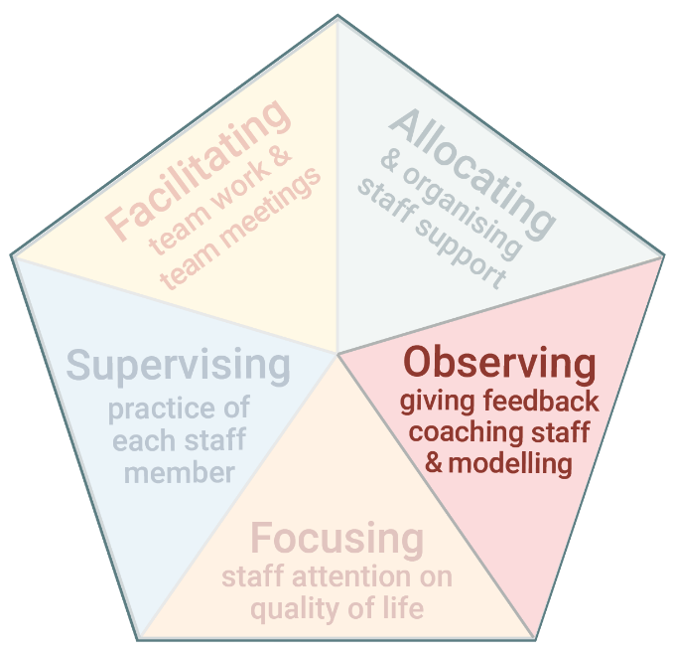 | ​The third task of Practice Leadership is observing staff, giving feedback, coaching, and modelling good practice.  ​By doing this task well, Practice Leaders help support workers to:  - Develop new skills.  - Refine existing skills.  - Reflect on their practice.  - Receive new ideas and suggestions.

www.practiceleadershipresource.com.au/module4

Module 4 - Part 1 Activities

Activity 4.1 Observing support
Watch the video Pool observation and make notes about the support you observe.

Activity 4.2 Thinking about feedback
Look at the notes you made for Activity 4.1 or watch the Pool observation video again.

Plan your feedback to the support worker. Use the questions presented in this module to guide your feedback.

Activity 4.3 Providing feedback
Watch the videos Poor feedback and Good feedback, and answer the following questions.
- How did the Practice Leader provide feedback in each of the scenarios?
- What were the differences between the way feedback was provided in the first and second scenarios?
- What was it like for the support worker in each of the scenarios?

