Module 6
Facilitating Team Work and Team Meetings

 | 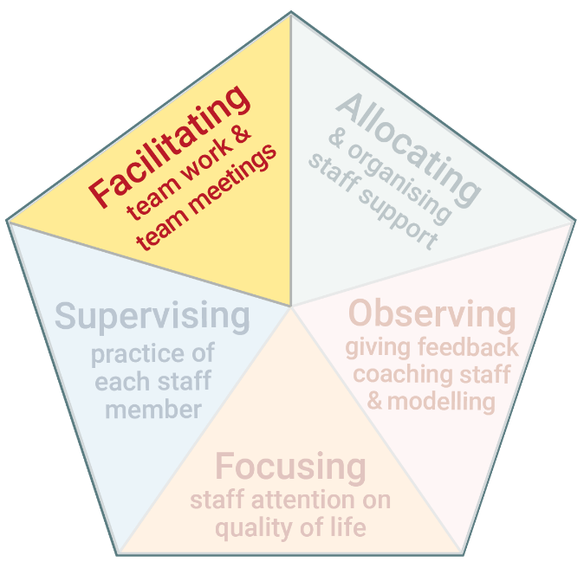 | The fifth task of Practice Leadership is to facilitate team work and chair team meetings.  ​​Frontline staff in disability services work in teams. Team members must work together, communicate, interact and problem solve collectively to achieve common goals. Team meetings enable these things to happen.

www.practiceleadershipresource.com.au/module6

Module 6 Activities
Watch the video Good team meeting and answer the following questions.
Activity 6.1 Chairing the meeting
- How did the Practice Leader direct the discussion on a person’s quality of life?
- How did the Practice Leader generate input from staff and discussion?
- What do you think of how team members interacted with each other?

Activity 6.2 Culture
Read the Characteristics of staff culture presented in the table in this module.
Reflect on the culture in the team you lead and answer the following questions.
- What are the key characteristics of the staff team?
- How do the characteristics compare with those presented in the table in this module?
- In what ways is the team culture positive? In what ways could it be improved?

