Frontline Practice Leadership

Activity Workbook

Develop your skills in Frontline Practice Leadership
Improve the practice of support workers and the quality of life of people with intellectual disabilities.

This training resource is for frontline supervisors, service managers, and experienced support workers.

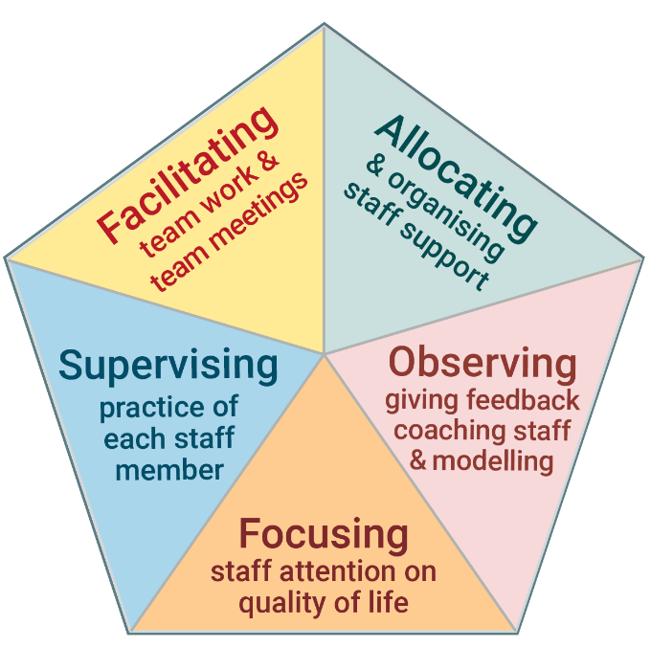 | You will learn how to:  - Observe the practice of disability support workers and give them constructive feedback.  - Have productive discussions with staff in supervision.  - Run effective team meetings.  - Help staff to develop their support skills.  - Embed Active Support in services.  - Deliver well organised and consistent services​.

The activities in this workbook are from the Frontline Practice Leadership online training resource:
www.practiceleadershipresource.com.au
Module 1
What is Frontline Practice Leadership?

Frontline Practice Leadership is the set of five tasks that are critical to ensuring good quality support for people with intellectual disabilities.

The five tasks of Frontline Practice Leadership are shown in the diagram.

www.practiceleadershipresource.com.au/module1

Module 1 Activity
Look at the five tasks of Practice Leadership shown in the diagram above. Think about where you work and answer the following questions. ​
- Which of the five tasks are you responsible for?​
- If you are not responsible for all five tasks, who is responsible for the other tasks?
- Which of the tasks do you think you are performing well?
- Which of the tasks do you think you can improve?
- In what ways is the service/s you manage performing well?
- In what ways could the service/s you manage improve?

Module 2
​Focusing Staff Attention on Quality of Life

 | 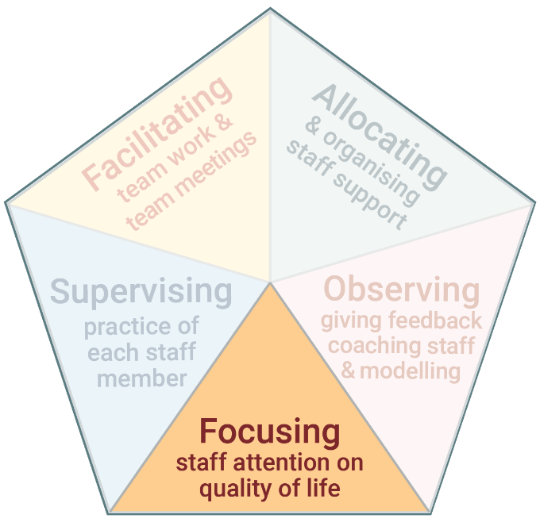 | ​​The first task of Practice Leadership is focusing staff attention on quality of life.  ​It is about ensuring the primary focus of the service and staff is on the quality of life of the people you support.​

www.practiceleadershipresource.com.au/module2

Module 2 Activities
Watch the videos Michael’s quality of life and Gerard’s quality of life, and answer the following questions.
Activity 2.1 Individual quality of life
- What did Michael identify as important to his quality of life?
- What did Gerard identify as important to his quality of life?
- Use the 8 domains of quality of life and think about a person you support: What would the person identify as important to their quality of life?
- Think about the service and supports this person receives: In what ways do they contribute to the person’s quality of life?
- In what ways could the service and support be improved so the person experiences better quality of life?

Activity 2.2 Staff support, engagement and quality of life
Watch the video Maree’s support and answer the following questions.
- How did the support worker (Sophie) see the purpose of her role?
- How did the Practice Leader help the support worker to think about Maree’s quality of life?

Module 3
​Allocating and Organising Staff

 | 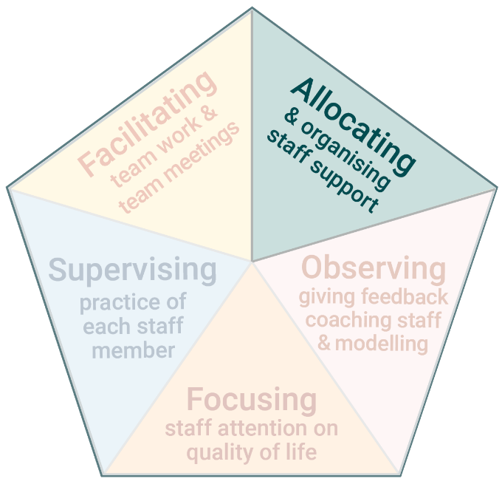 | ​​The second task of Practice Leadership is Allocating and Organising staff.  ​Frontline Practice Leaders organise and support staff to work individually and as a team. This helps ensure:  - Support is provided when and how each person you support wants and needs it.  - Consistency across staff in the way they work and provide support.

www.practiceleadershipresource.com.au/module3

Module 3 Activities
Watch the video Poor shift planning and answer the following questions.
Activity 3.1 Poor shift planning
- What problems did you see with the way staff were organised in this scenario?
- What impact did it have on each person who was being supported?
- If you were the Frontline Practice Leader in this service, what would you do to improve how staff were organised?

Activity 3.2 Good shift planning
Watch the video Good shift planning and answer the following questions.
- What did the staff do differently in this scenario, compared to the previous video?
- What impact did it have on each person who was being supported?
- If you were the Frontline Practice Leader, how would you set the expectation that this way of planning and organising among staff needs to happen every shift?

Activity 3.3 Inconsistent support
Watch the video Coffee three ways and answer the following questions.
- What would it be like for the person receiving support in three different ways to make their coffee?
- Imagine you are the Practice Leader in this service: What would you do to establish consistency in how staff support this person to make his coffee?

Module 4 – Part 1
Observing Staff, Giving Feedback,
Coaching and Modelling Good Practice

 | 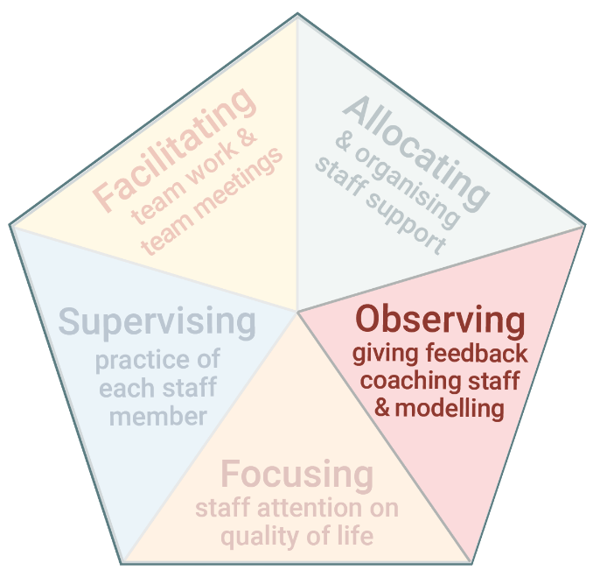 | ​The third task of Practice Leadership is observing staff, giving feedback, coaching, and modelling good practice.  ​By doing this task well, Practice Leaders help support workers to:  - Develop new skills.  - Refine existing skills.  - Reflect on their practice.  - Receive new ideas and suggestions.

www.practiceleadershipresource.com.au/module4

Module 4 - Part 1 Activities

Activity 4.1 Observing support
Watch the video Pool observation and make notes about the support you observe.

Activity 4.2 Thinking about feedback
Look at the notes you made for Activity 4.1 or watch the Pool observation video again.

Plan your feedback to the support worker. Use the questions presented in this module to guide your feedback.

Activity 4.3 Providing feedback
Watch the videos Poor feedback and Good feedback, and answer the following questions.
- How did the Practice Leader provide feedback in each of the scenarios?
- What were the differences between the way feedback was provided in the first and second scenarios?
- What was it like for the support worker in each of the scenarios?

Module 4 – Part 2
Observing Staff, Giving Feedback,
Coaching and Modelling Good Practice

Modelling and Coaching

​Part 2 of this module is modelling and coaching.
- Modelling and coaching are used to demonstrate or teach staff good support practices.

www.practiceleadershipresource.com.au/module4-part2

Module 4 – Part 2 Activity
Watch the video Coaching and answer the following questions.
- Think about a support worker who would like or would benefit from coaching.
- Plan how, when and where you would provide coaching to this support worker.
- Think about how you would use the steps presented in this module to provide coaching to this support worker.

Module 5
Supervising Practice of Each Staff Member

 | 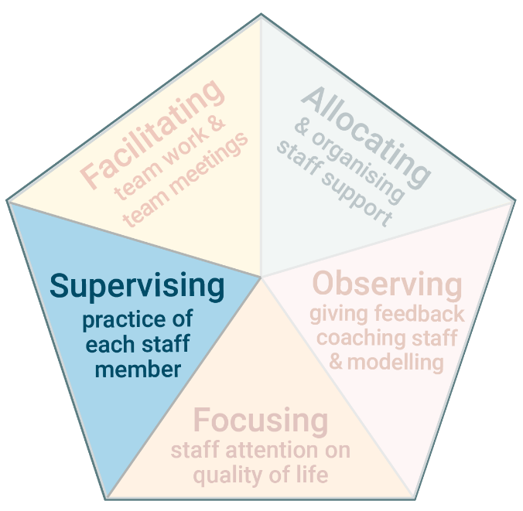 | The fourth task of Practice Leadership is supervising staff.  ​Supervision means the Frontline Practice Leader and a support worker have a deep and focused discussion about the support worker’s practice. Supervision guides and develops the support worker’s practice.

www.practiceleadershipresource.com.au/module5

Module 5 Activities
Look at the diagram and read about the different types of supervision, and answer the following questions.
Activity 5.1 Different types of supervision
- What type of supervision do you most frequently have with staff?
- How well is this type of supervision meeting the needs of staff?
- Is there another type of supervision that you are currently not using which would be beneficial for staff?
- How could you make use of this type of supervision?

Activity 5.2 Planned formal supervision
Watch the video Planned formal supervision and answer the following questions.
- What was discussed in the supervision session in the video?
- How did the Practice Leader direct the conversation and help the support worker to reflect and problem solve?
- What do you think this supervision was like for the support worker?

Activity 5.3 Unplanned formal supervision
Watch the video Unplanned informal supervision and answer the following questions.
- How does the Practice Leader use the skills of asking questions in this conversation?

- Think about where you work. When and how often are there opportunities for unplanned informal supervision with the staff you manage?

Module 6
Facilitating Team Work and Team Meetings

 | 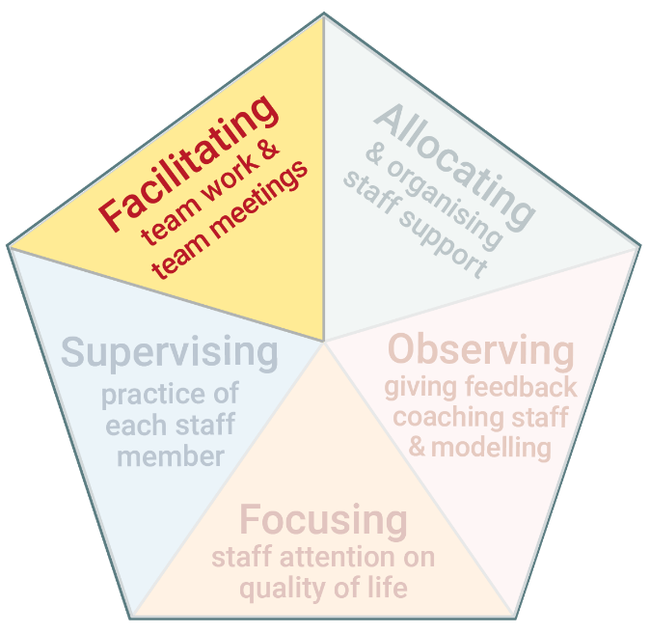 | The fifth task of Practice Leadership is to facilitate team work and chair team meetings.  ​​Frontline staff in disability services work in teams. Team members must work together, communicate, interact and problem solve collectively to achieve common goals. Team meetings enable these things to happen.

www.practiceleadershipresource.com.au/module6

Module 6 Activities
Watch the video Good team meeting and answer the following questions.
Activity 6.1 Chairing the meeting
- How did the Practice Leader direct the discussion on a person’s quality of life?
- How did the Practice Leader generate input from staff and discussion?
- What do you think of how team members interacted with each other?

Activity 6.2 Culture
Read the Characteristics of staff culture presented in the table in this module.
Reflect on the culture in the team you lead and answer the following questions.
- What are the key characteristics of the staff team?
- How do the characteristics compare with those presented in the table in this module?
- In what ways is the team culture positive? In what ways could it be improved?

This concludes the activities for the Frontline Practice Leadership online training resource.

Additional free online training resources developed by the Living with Disability Research Centre at La Trobe University include:
- Every moment has potential – Active Support
- Enabling risk
- Supporting inclusion
- Support for decision making

