Module 1
What is Frontline Practice Leadership?

 | 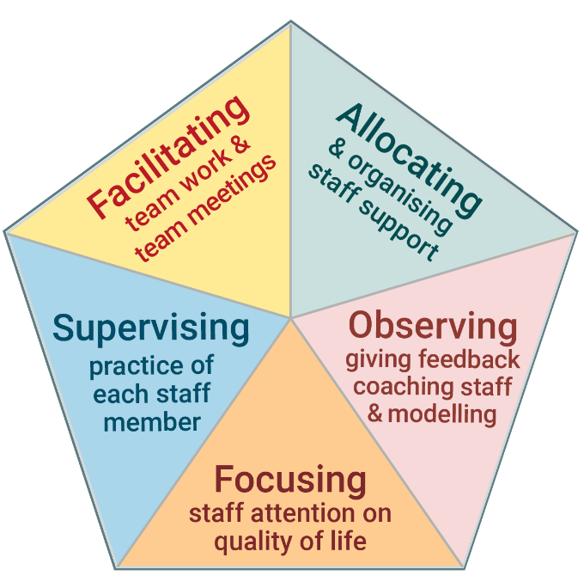 | Frontline Practice Leadership is the set of five tasks that are critical to ensuring good quality support for people with intellectual disabilities.  The five tasks of Frontline Practice Leadership are shown in the diagram.

www.practiceleadershipresource.com.au/module1

Module 1 Activity
Look at the five tasks of Practice Leadership shown in the diagram above. Think about where you work and answer the following questions. ​
- Which of the five tasks are you responsible for?​
- If you are not responsible for all five tasks, who is responsible for the other tasks?
- Which of the tasks do you think you are performing well?
- Which of the tasks do you think you can improve?
- In what ways is the service/s you manage performing well?
- In what ways could the service/s you manage improve?

