Module 2
​Focusing Staff Attention on Quality of Life

 | 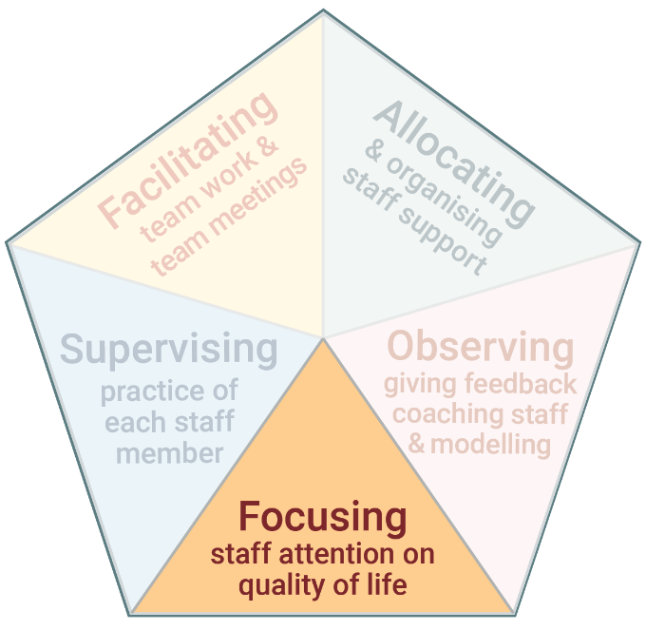 | ​​The first task of Practice Leadership is focusing staff attention on quality of life.  ​It is about ensuring the primary focus of the service and staff is on the quality of life of the people you support.​

www.practiceleadershipresource.com.au/module2

Module 2 Activities
Watch the videos Michael’s quality of life and Gerard’s quality of life, and answer the following questions.
Activity 2.1 Individual quality of life
- What did Michael identify as important to his quality of life?
- What did Gerard identify as important to his quality of life?
- Use the 8 domains of quality of life and think about a person you support: What would the person identify as important to their quality of life?
- Think about the service and supports this person receives: In what ways do they contribute to the person’s quality of life?
- In what ways could the service and support be improved so the person experiences better quality of life?

Activity 2.2 Staff support, engagement and quality of life
Watch the video Maree’s support and answer the following questions.
- How did the support worker (Sophie) see the purpose of her role?
- How did the Practice Leader help the support worker to think about Maree’s quality of life?

