Module 4 – Part 2
Observing Staff, Giving Feedback,
Coaching and Modelling Good Practice

 | 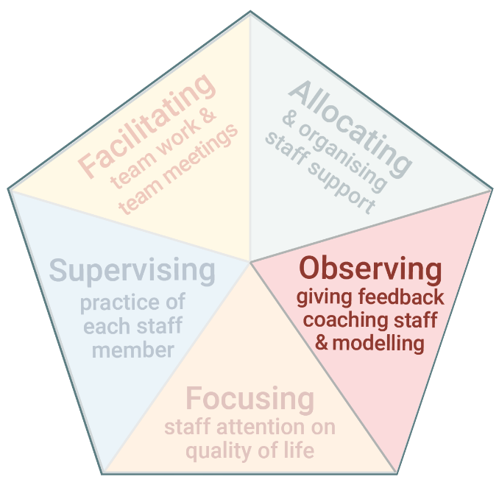 | Modelling and Coaching  ​Part 2 of this module is modelling and coaching.  - Modelling and coaching are used to demonstrate or teach staff good support practices.

www.practiceleadershipresource.com.au/module4-part2

Module 4 – Part 2 Activity
Watch the video Coaching and answer the following questions.
- Think about a support worker who would like or would benefit from coaching.
- Plan how, when and where you would provide coaching to this support worker.
- Think about how you would use the steps presented in this module to provide coaching to this support worker.

