Module 5
Supervising Practice of Each Staff Member

 | 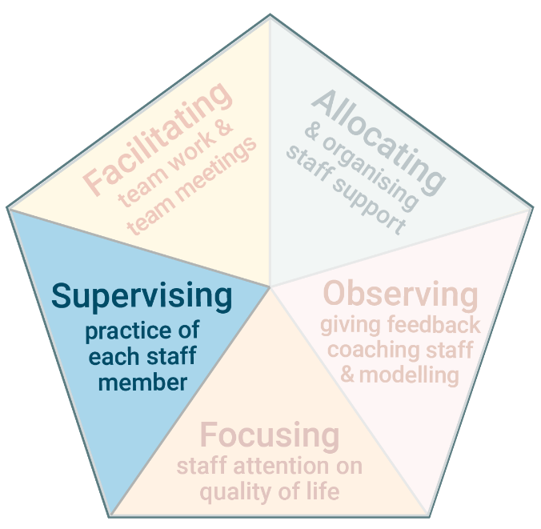 | The fourth task of Practice Leadership is supervising staff.  ​Supervision means the Frontline Practice Leader and a support worker have a deep and focused discussion about the support worker’s practice. Supervision guides and develops the support worker’s practice.

www.practiceleadershipresource.com.au/module5

Module 5 Activities
Look at the diagram and read about the different types of supervision, and answer the following questions.
Activity 5.1 Different types of supervision
- What type of supervision do you most frequently have with staff?
- How well is this type of supervision meeting the needs of staff?
- Is there another type of supervision that you are currently not using which would be beneficial for staff?
- How could you make use of this type of supervision?

Activity 5.2 Planned formal supervision
Watch the video Planned formal supervision and answer the following questions.
- What was discussed in the supervision session in the video?
- How did the Practice Leader direct the conversation and help the support worker to reflect and problem solve?
- What do you think this supervision was like for the support worker?

Activity 5.3 Unplanned formal supervision
Watch the video Unplanned informal supervision and answer the following questions.
- How does the Practice Leader use the skills of asking questions in this conversation?

- Think about where you work. When and how often are there opportunities for unplanned informal supervision with the staff you manage?

